***Material Balance at a junction:***

$$Input-Output+Generation–Consumption= Accumulation (1)$$

There was no generation or consumption of passengers so these terms were irrelevant. The accumulation term led to an unsteady state material balance.

So, equation **(1)** reduces to:

$$Input – Output = Accumulation$$

*Or,*

$I-O=\frac{dm}{dt} (2)$

**The input of passengers** was based on passengers who walked into the junction from outside as well as due to those who got down at the junction from the trains of Line 1 and Line 2.

**The output of passengers** was due to the riders who walked out of the junction to the outside as well as those on the train that left the junction for the subsequent station.

**Accumulation term (m: number of passengers**) was dependent on the passengers present at the junction at any given time.

Therefore, equation **(2)** can be rewritten as:

$\left(I_{train in}+I_{walk in}\right)-\left(O_{train out}+O_{walk out}\right)=\frac{dm}{dt}$

Or the above equation can be rearranged as:

$\left(I_{train in}-O_{train out}\right)+\left(I_{walk in}-O_{walk out}\right)=\frac{dm}{dt} (3)$

Note that all the terms including input, output and accumulation are rates (passengers/hour).

To solve equation **(3)**, it was required to first find the number of trains that entered the junction during peak and non-peak hours:

**For peak hours:** Train frequency = 1 train/167 seconds; Dwell time = 30 seconds

Say at time t = 0, 1st train entered and waited for 30 seconds;

At t = 197 seconds, 2nd train entered

So, in one hour, trains that entered the junction = 3600/197 = **18 trains**

During peak hours it was calculated that there was 18 trains/hour (train rate) at any platform.

**For non-peak hours:** Train frequency = 1 train/196 seconds; Dwell time = 30 seconds

Say at time t = 0, 1st train entered and waited for 30 seconds

At t = 226 seconds, 2nd train entered

So, in one hour, trains that entered the junction = 3600/226 = **16 trains**

During non-peak hours it was calculated that there was 16 trains/hour (train rate) at any platform. The above data was used along with equation **(3)** to solve the accumulation of passengers at that particular junction. Both of Line 2 (Yellow Line), one at a time and then collectively, were observed to find the total effect on the system.

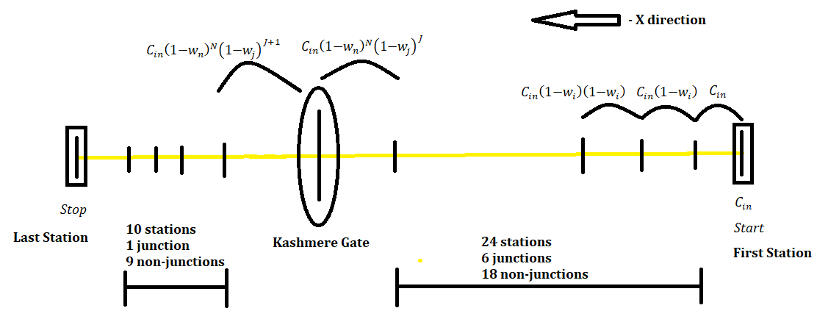

***Figure 3.*** A schematic representation of the total passengers’ inflow and outflow in the (negative) -X direction.

The number of passengers brought in at second station:

$$C_{in}=C$$

Total capacity (Cin) was equal to the total train capacity because the train started at the first station and therefore, no passengers got off at that station.

The net number of passengers getting down at any station were:

${ n}_{passengers down}=w_{i}*C_{in} (4)$

where;

$w_{i}$: weight of a station class $i$ ( $i$ =j for junction; $i$ =n for non-junction)

$C_{in}$: train capacity before entering the station (or number of passengers brought in by the train at that particular station)

Number of passengers taken out of the second station (or arriving at the third station) by the train:

$C_{out}={C_{in}-w}_{i}*C_{in}=C_{in}\left(1{-w}_{i}\right) (5)$

Number of passengers taken out of the third station (or arriving at the fourth station) by the train:

$${ C}_{out}={C_{in}\left(1{-w}_{i}\right)-w}_{i}*C_{in}\left(1{-w}_{i}\right)=C_{in}\left(1{-w}_{i}\right)\left(1{-w}_{i}\right) (6)$$

Using equations **(5)** and **(6)**, number of passengers that arrived at Kashmere Gate (or the number of passengers taken out of Kashmere Gate’s previous station by the train) were:

$$C_{KG in}={C_{in}\left(1{-w}_{i}\right)}^{T} (7)$$

where;

$T$: total number of stations before Kashmere Gate, excluding the first two stations (because $\left(1{-w}_{i}\right)$ the term came into the equation from the third station. See equation **(5)**)

$T=N+J (8)$

where;

$N$: Number of non-junctions

$J$: Number of junctions

Using equation **(8)**, equation **(7)** was rewritten as:

$$C_{KG in}={C_{in}\left(1{-w}_{n}\right)}^{N}{\left(1{-w}_{j}\right)}^{J} (9)$$

$$C_{KG out}={C_{in}\left(1{-w}_{n}\right)}^{N}{\left(1{-w}_{j}\right)}^{J+1} (10)$$

Using equations **(9)** and **(10)**, values were assigned to the mass balance equation **(3)** at Kashmere Gate junction:

$$I_{train in} =C_{KG in}*\left(train rate\right)$$

${O_{train out}=C}_{KG out}*\left(train rate\right)$

We multiplied them by train rate (different for peak and non-peak hours as calculated in the previous section) since we required the total number of passengers brought in or taken out by trains every hour.

The assumption was that some percentage of the passengers that got off, walked out of the junction (represented by $r_{walk out}$, where r is the ratio) while the remaining percentage stayed at the junction (represented by $r_{walk in}$) for some reason (like waiting for the connecting train or eating at food stalls). Those passengers who stayed contributed to accumulation at the junction (added these to the passengers walking in).

It was assumed that the number of passengers walking into the junction is the same as those left behind at the junction ($r_{walk in}$).

$O_{walk out}=r_{walk out}*\left(I_{train in}-O_{train out}\right)$

$I_{walk in}=r_{walk in}*\left(I_{train in}-O_{train out}\right)*2$

We solved for both peak and non-peak hours and then considered their combined average to get average hourly values for the above variables.

The calculations for +X-direction would be similar to the ones for -X-direction above. The values of $C_{KG in}$ and $C_{KG out}$ differed as the equation **(8)** changed for +X-direction. This was because the number of junctions and non-junctions before Kashmere Gate would be different as compared to the number in -X-direction.

$${ I}_{train in} =C_{KG in}*\left(train rate\right)$$

${O_{train out}=C}_{KG out}*\left(train rate\right)$

$$O_{walk out}=r_{walk out}*\left(I_{train in}-O_{train out}\right)$$

$$I_{walk in}=r_{walk in}*\left(I_{train in}-O_{train out}\right)*2$$

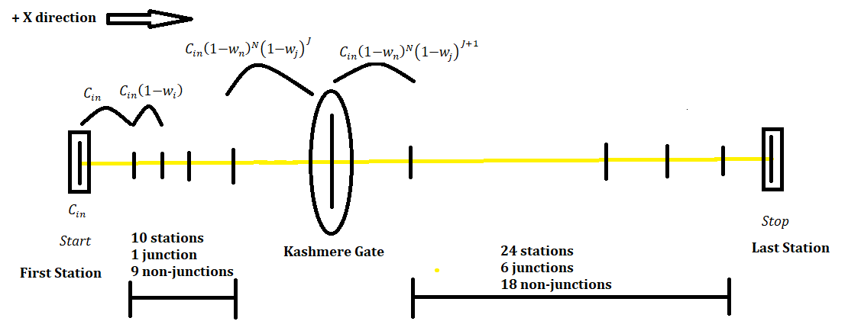

***Figure 4.*** A schematic representation of the total passengers’ inflow and outflow in the (positive) +X direction.

We solved for both peak and non-peak hours and then considered their combined average to get average hourly values for the above variables.

For both –X and +X direction together:

$$I_{train in} =I_{train in, +X}+I_{train in, -X}$$

$$O_{train out}=O_{train out, +X}+O_{train out, -X}$$

$${ O}_{walk out}=O_{walk out, +X}+O_{walk out, -X}$$

$$I_{walk in}=I_{walk in, +X}+I_{walk in, -X}$$

Substituting these values in equation **(3)**:

$$\left(I_{train in}-O_{train out}\right)+\left(I_{walk in}-O_{walk out}\right)=\frac{dm}{dt}$$